WEEK 3

Question 1:

Same Digit

Problem Statement:

Write a program to read two integer values and print true if both the numbers end with

the same digit, otherwise print false.

Example: If 698 and 768 are given, program should print true as they both end with 8.

Sample Input 1

25 53

Sample Output 1

false

Sample Input 2

27 77

Sample Output 2

True

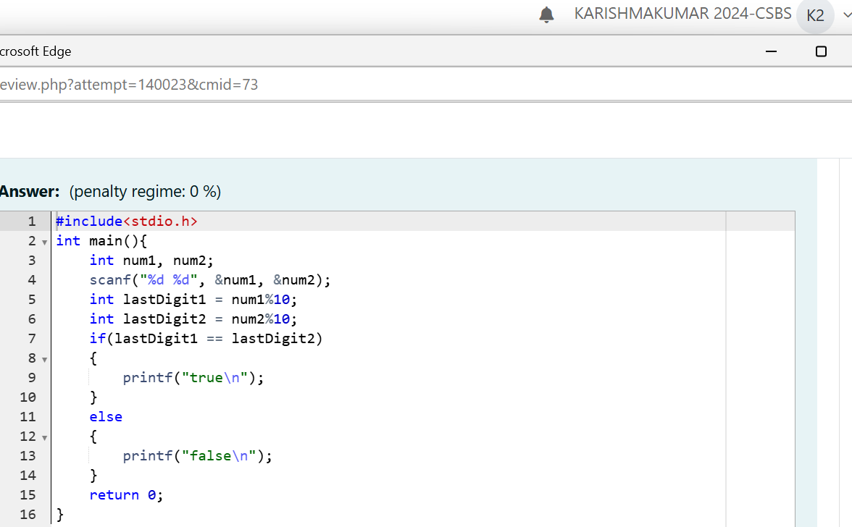

Output:

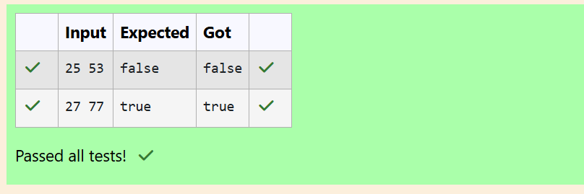

Question 2:

Intro to Conditional Statements

Problem Statement:

In this challenge, we're getting started with conditional statements.

Task

Given an integer, n, perform the following conditional actions:

• If n is odd, print Weird

• If n is even and in the inclusive range of 2 to 5, print Not Weird

• If n is even and in the inclusive range of 6 to 20, print Weird

• If n is even and greater than 20, print Not Weird

Complete the stub code provided in your editor to print whether or not n is weird.

Input Format

A single line containing a positive integer, n.

Constraints

• 1 < n < 100

Output Format

Print Weird if the number is weird; otherwise, print Not Weird.

Sample Input 0

3

Sample Output 0

Weird

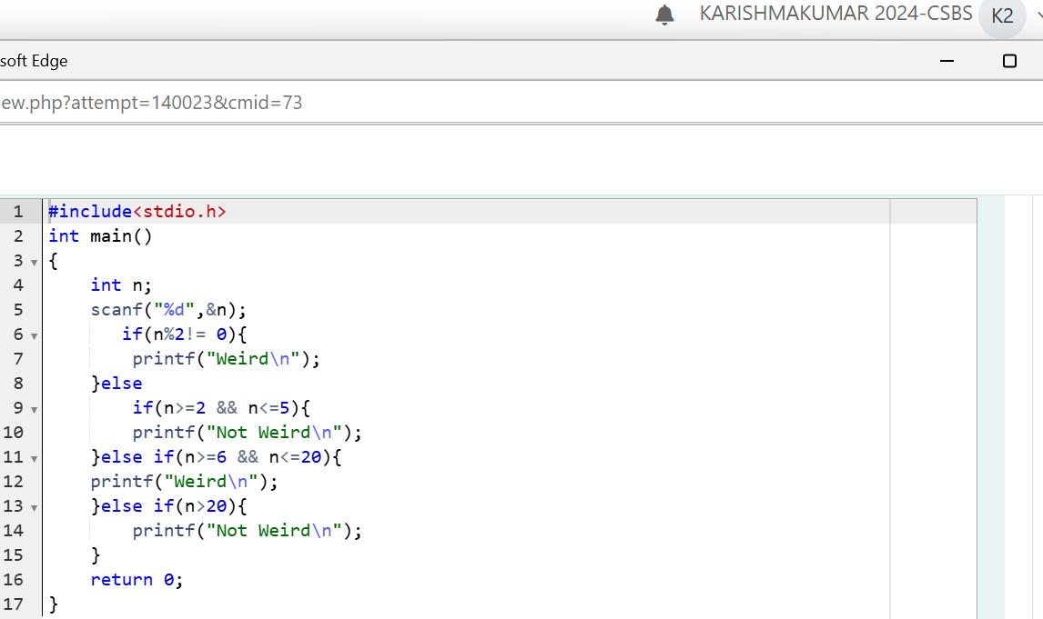

Output:

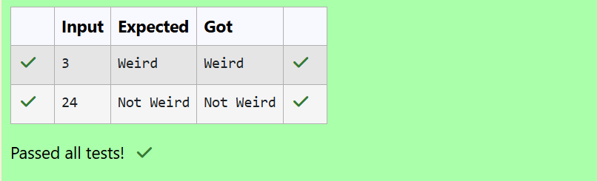

Question 3:

Pythagorean Triples

Problem Statement:

Three numbers form a Pythagorean triple if the sum of squares of two numbers is equal to

the square of the third.

For example, 3, 5 and 4 form a Pythagorean triple, since 3\*3 + 4\*4 = 25 = 5\*5

You are given three integers, a, b, and c. They need not be given in increasing order. If

they form a Pythagorean triple, then print "yes", otherwise, print "no". Please note that the

output message is in small letters.

Sample Input 1

3

5

4

Sample Output 1

Yes

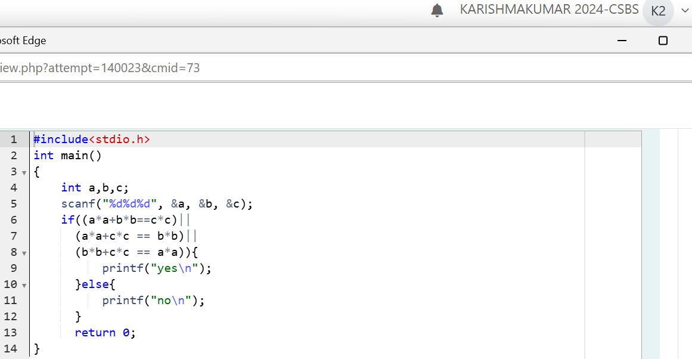

Output:

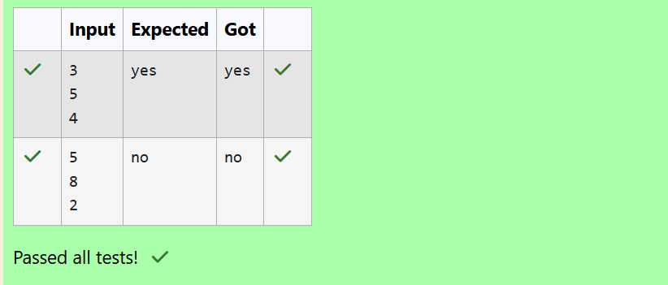

Question 4:

Chinese Zodiac

Problem Statement:

The Chinese zodiac assigns animals to years in a 12-year cycle. One 12-year cycle is

shown in the table below. The pattern repeats from there, with 2012 being another year of

the Dragon, and 1999 being another year of the Hare.

Year Animal

2000 Dragon

2001 Snake

2002 Horse

2003 Sheep

2004 Monkey

2005 Rooster

2006 Dog

2007 Pig

2008 Rat

2009 Ox

2010 Tiger

2011 Hare

Write a program that reads a year from the user and displays the animal associated with

that year. Your program should work correctly for any year greater than or equal to zero,

not just the ones listed in the table.

Sample Input 1

2004

Sample Output 1

Monkey

Sample Input 2

2010

Sample Output 2

Tiger

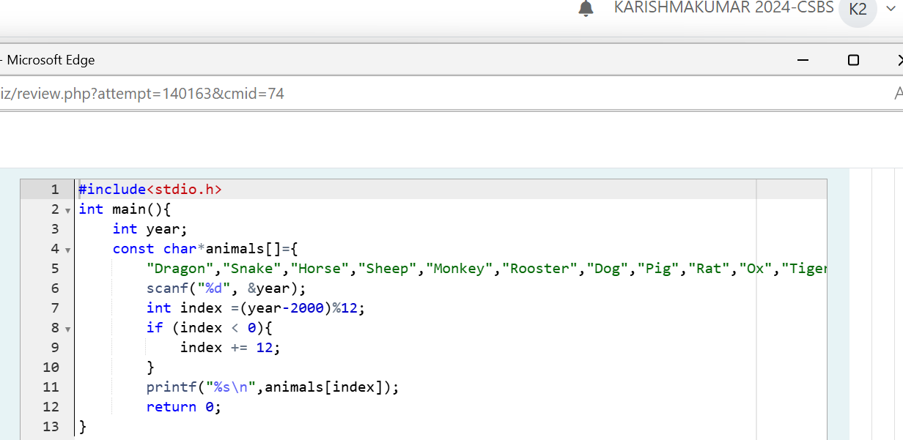

Output:

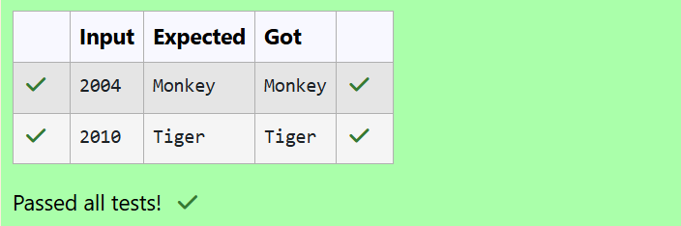

Question 5:

What Color Is That Square?

Problem Statement:

Positions on a chess board are identified by a letter and a number. The letter identifies the

column, while the number identifies the row, as shown below:

Write a program that reads a position from the user. Use an if statement to determine if the

column begins with a black square or a white square. Then use modular arithmetic to

report the color of the square in that row. For example, if the user enters a1 then your

program should report that the square is black. If the user enters d5 then your program

should report that the square is white. Your program may assume that a valid position will

always be entered. It does not need to perform any error checking.

Sample Input 1

a 1

Sample Output 1

The square is black.

Sample Input 2

d 5

Sample Output 2

The square is white

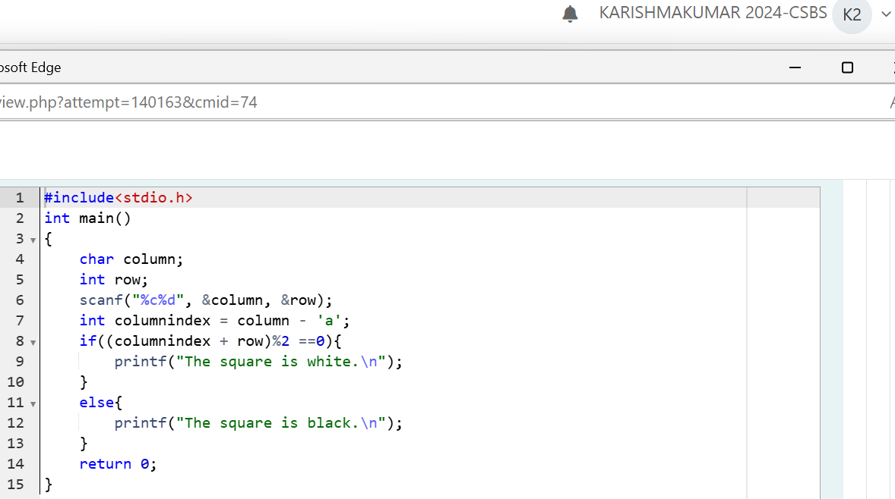

Output:

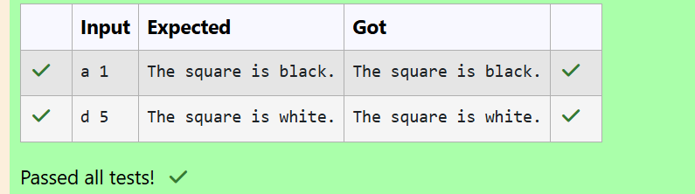

Question 6:

Day of Year

Problem Statement:

Some data sets specify dates using the year and day of year rather than the year, month,

and day of month. The day of year (DOY) is the sequential day number starting with day 1

on January 1st.

There are two calendars - one for normal years with 365 days, and one for leap years with

366 days. Leap years are divisible by 4. Centuries, like 1900, are not leap years unless

they are divisible by 400. So, 2000 was a leap year.

To find the day of year number for a standard date, scan down the Jan column to find the

day of month, then scan across to the appropriate month column and read the day of year

number. Reverse the process to find the standard date for a given day of year.

Write a program to print the Day of Year of a given date, month and year.

Sample Input 1

18

6

2020

Sample Output 1

170

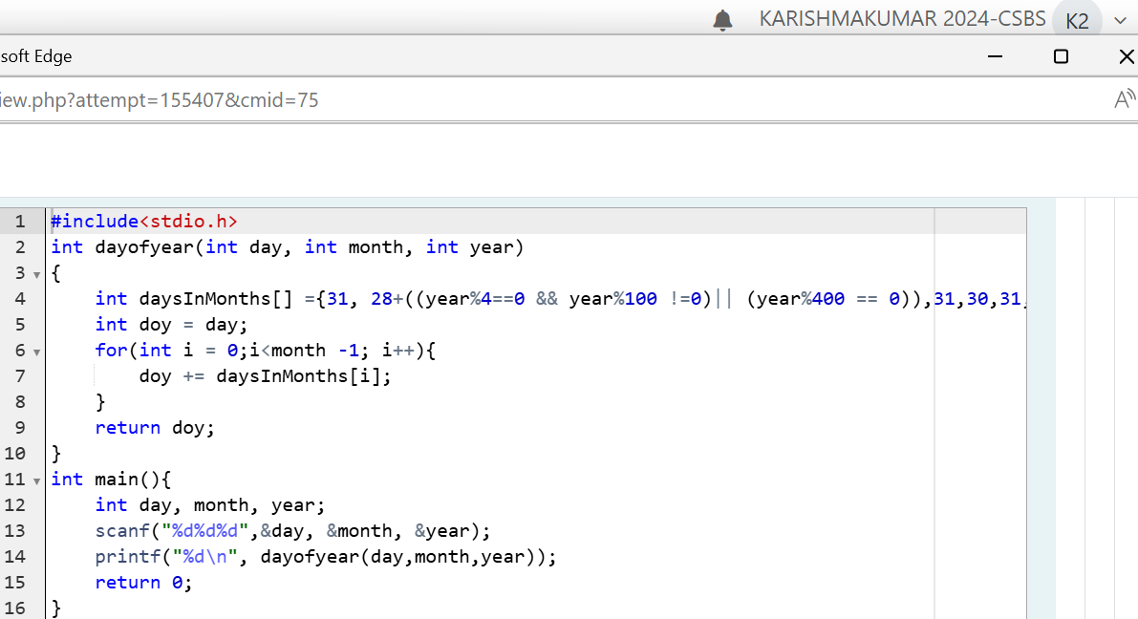

Output:

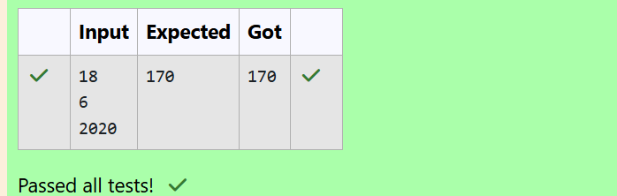

Question 7:

Suppandi & Areas

Problem Statement:

Suppandi is trying to take part in the local village math quiz. In the first round, he is asked

about shapes and areas. Suppandi, is confused, he was never any good at math. And also,

he is bad at remembering the names of shapes. Instead, you will be helping him calculate

the area of shapes.

• When he says rectangle, he is actually referring to a square.

• When he says square, he is actually referring to a triangle.

• When he says triangle, he is referring to a rectangle

• And when he is confused, he just says something random. At this point, all you can

do is say 0.

Help Suppandi by printing the correct answer in an integer.

Input Format

• Name of shape (always in upper case R --> Rectangle, S --> Square, T --> Triangle)

• Length of 1 side

• Length of other side

Note: In case of triangle, you can consider the sides as height and length of base

Output Format

• Print the area of the shape.

Sample Input 1

T

10

20

Sample Output 1

200

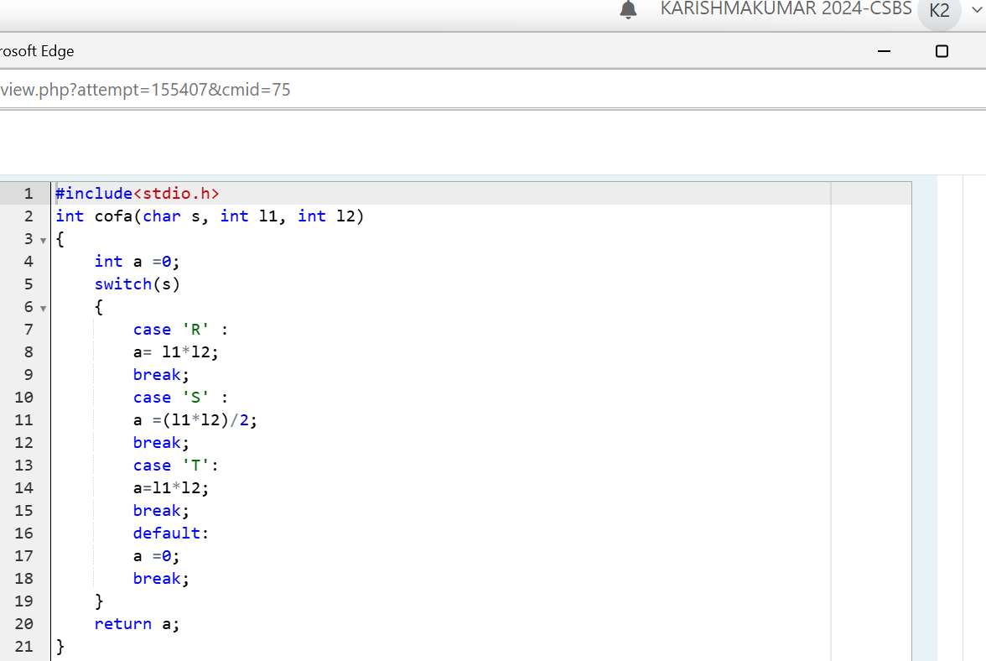

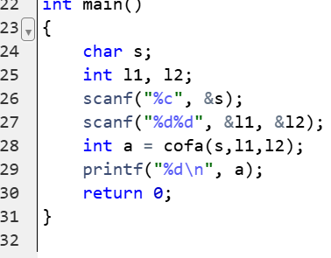

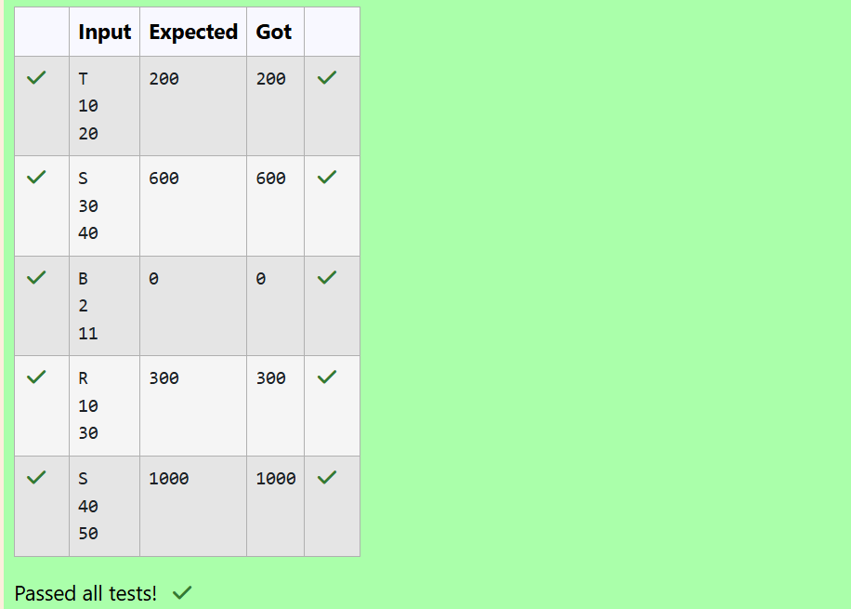

Question 8:

Superman's Encounter

Problem Statement:

Superman is planning a journey to his home planet. It is very important for him to know

which day he arrives there. They don't follow the 7-day week like us. Instead, they follow

a 10-day week with the following days:

Day Number Name of Day

1 Sunday

2 Monday

3 Tuesday

4 Wednesday

5 Thursday

6 Friday

7 Saturday

8 Kryptonday

9 Coluday

10 Daxamday

Here are the rules of the calendar:

• The calendar starts with Sunday always.

• It has only 296 days. After the 296th day, it goes back to Sunday.

You begin your journey on a Sunday and will reach after n. You have to tell on which day

you will arrive when you reach there.

Input format:

• Contain a number n (0 < n)

Output format:

Print the name of the day you are arriving on

Sample Input

7

Sample Output

Kryptonday

Sample Input

1

Sample Output

Monday

